**Practical – 3**

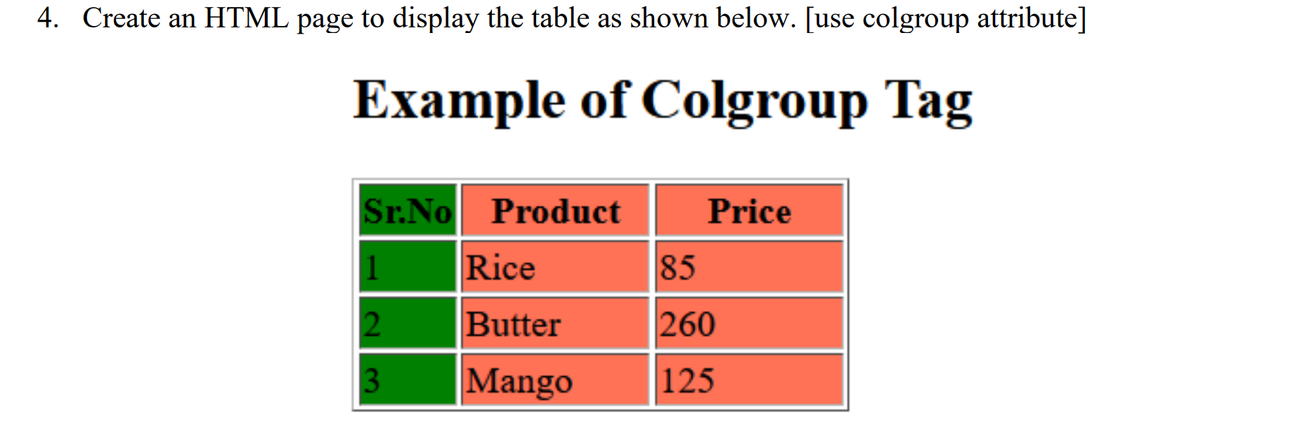

**HTML Code**

<!DOCTYPE html>

<html lang="en">

<head>

<meta charset="UTF-8">

<meta name="viewport" content="width=device-width, initial-scale=1.0">

<title>Rowspan & Colspan </title>

</head>

<body>

<center>

<h1>Example of Colgroup Tag</h1>

<table border="1" height="200px" width="500px">

<colgroup>

<col style="background-color: green;">

<col span="2" style="background-color: chocolate;">

</colgroup>

<tr>

<th>Sr.No</th>

<th>Product</th>

<th>Price</th>

</tr>

<tr>

<td>1</td>

<td>Rice</td>

<td>85</td>

</tr>

<tr>

<td>2</td>

<td>Butter</td>

<td>260</td>

</tr>

<tr>

<td>3</td>

<td>Mango</td>

<td>125</td>

</tr>

</table>

</center></body>

</html>

**Output**

